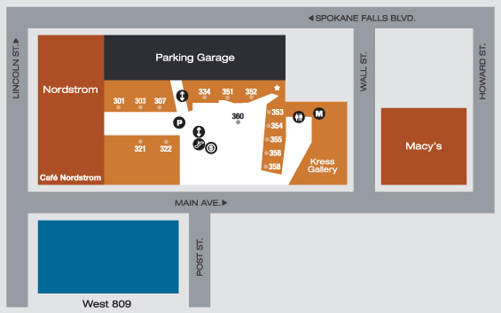

**Directions for those staying at the Davenport: Head north past our Peyton office on 10 N Post, cross Main, and go into River Park Square.**

**Go up the escalator to the 3rd floor to the Kress Gallery located at 808 W Main Ave**